
The Office of Workers' Compensation Programs administers four major disability compensation programs which provide wage replacement benefits, medical treatment, vocational rehabilitation and other benefits to certain workers or their dependents that experience work-related injury or occupational disease. The three OWCP Programs that participate in the Medical Bill Processing are:

- Division of Federal Employees' Compensation (DFEC)
- Division of Energy Employees Occupational Illness Compensation (DEEOIC)
- Division of Coal Mine Workers' Compensation (DCMWC)

In order to service our injured employees, providers must enroll with OWCP’s Medical Bill Processing Contractor.
Electronic Functionality:
Doing business electronically saves your practice time and money. Visit our Web Portal @ https://owcpmed.dol.gov/portal/main.do
You can access the following information online:
- Provider enrollment
- Access to bill processing
- Authorization access
- Electronic billing
- Electronic payments
- Remittance Vouchers
- Online fee schedule
- Online tutorials

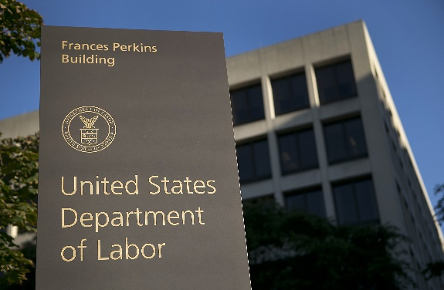
We Value Your Partnership!
You are essential to the care provided to claimants and play an important role as our partner in improving the quality of care for OWCP claimants. The Department of Labor is committed to helping our claimants’ access to the highest quality physicians, hospitals and other healthcare providers. Offering the best medical treatment features.
We offer the following services to assist you:
- Online Functionality
- One day Authorizations
- One of the shortest application process in the industry
- Reimbursement amounts above Medicare
- 24-hr. Pharmacy call center
- Resource Centers – DEEOIC
OWCP Primary Pricing Methodologies:
- DRG – Diagnosis Related Grouper
- CCR – Cost of Charge Ratio
- AWP – Average Wholesale Pricing (Pharmacy)
- OPPS – Outpatient Perspective Payment System
- ASC – Ambulatory Surgical Center
- Pay as Billed
- Anesthesia Fee Schedule

